Name: Vinod Pulickal
ID:

Task 1 – Load the Data into ChatGPT & add the main prompt (role, instruction, context, output indicator)
Prompt:
Role:
You are an expert data analyst who specialized in Python and generating awesome data visualization with insights.
Instruction:
Use the attached dataset on which I will share some tasks to be performed and you need to generate the Python code that needs to executed in Google Colab. Only answer once I ask the question. Ensure that the code is running without errors, is logically divided into cells since we are using Google Colab and is well commented.
The 8 important columns are survived, pclass, sex, age, sibsp, parch, fare, alone.
All the further analysis will be done on these important columns only
Screenshot:
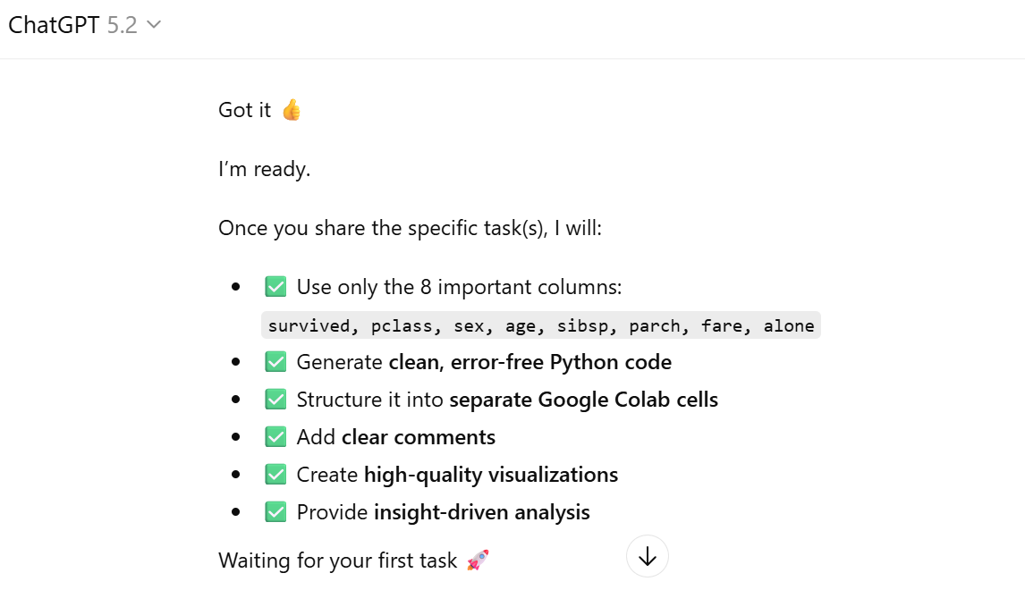

Task 2 – Choose 5 important columns & perform Basic Statistics (Mean, Median, Mode, Std Dev, Min, Max)
Prompt:
Task 1. Please do the descriptive analysis on these columns

Screenshot:
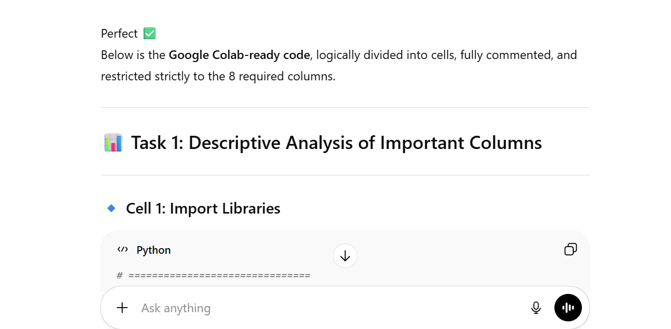
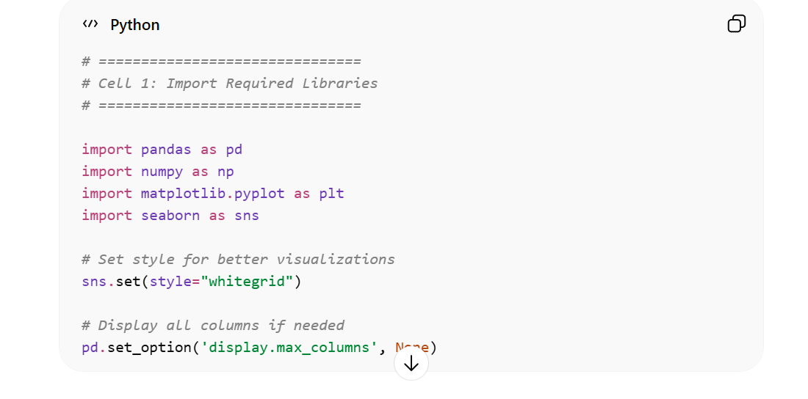

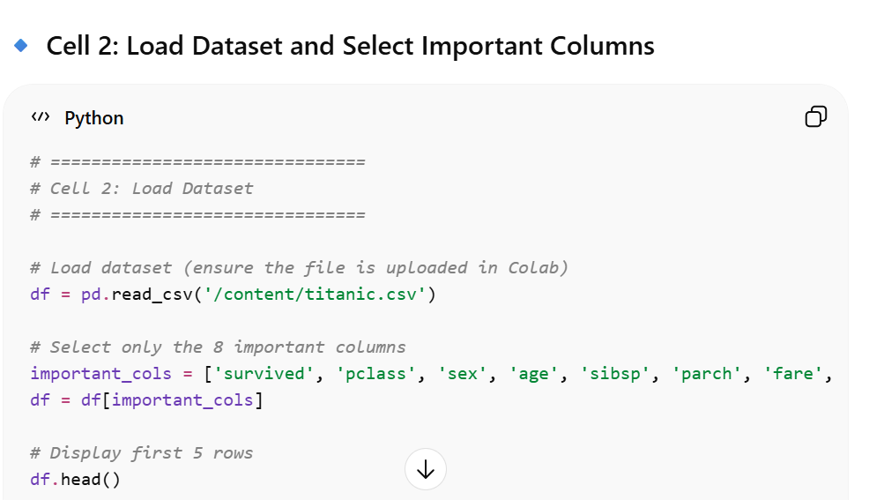
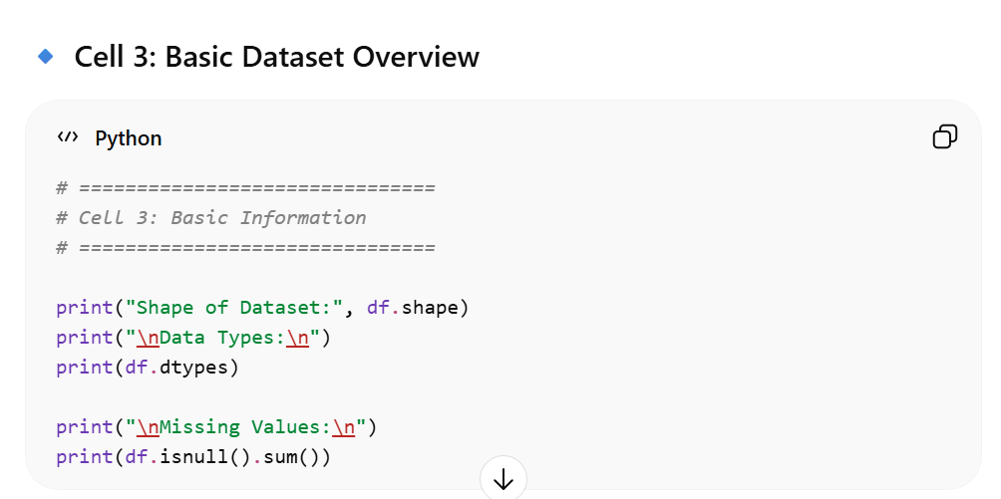
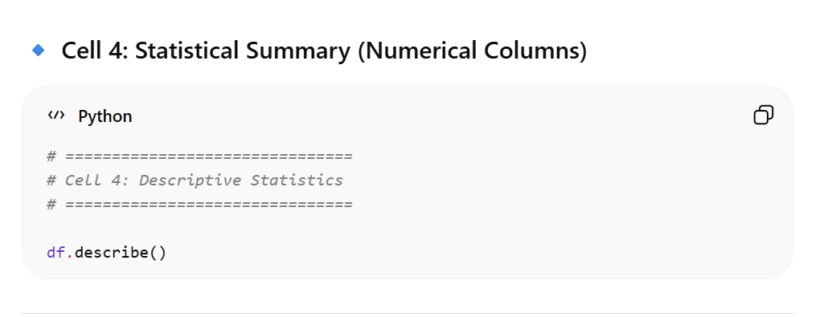
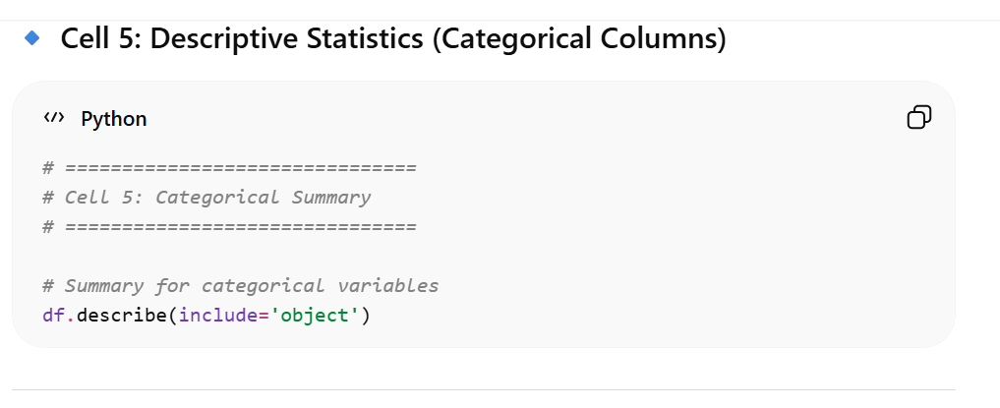
🔹 Cell 6: Survival Distribution
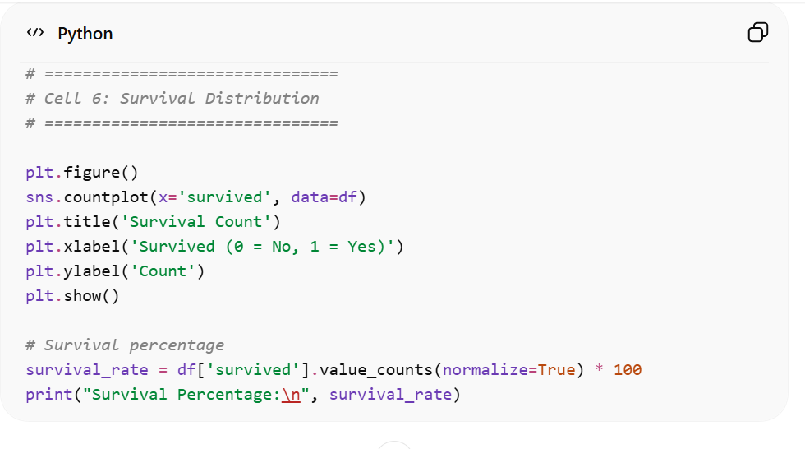

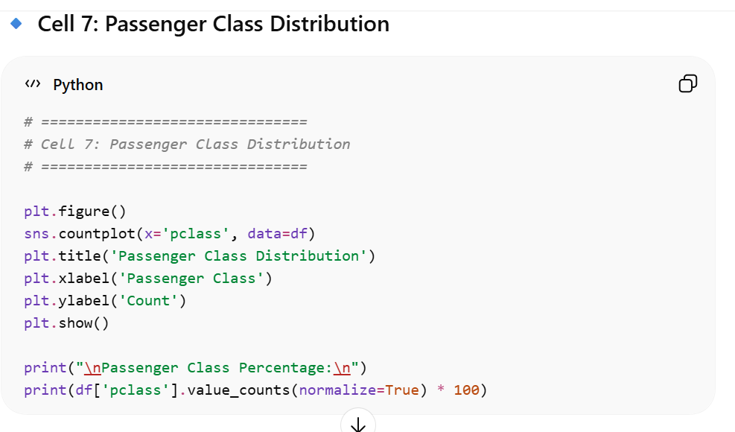
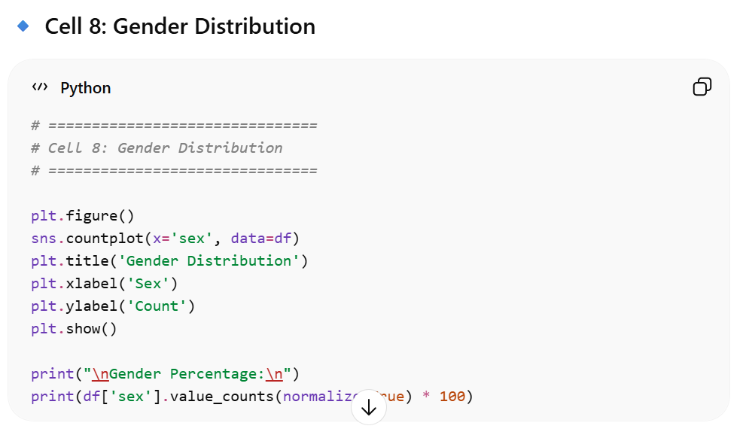
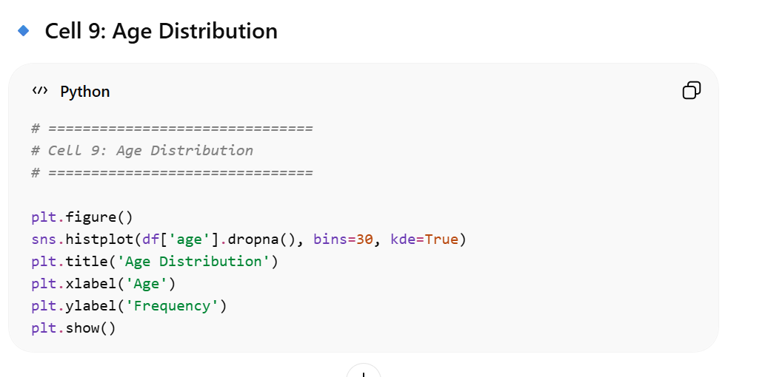
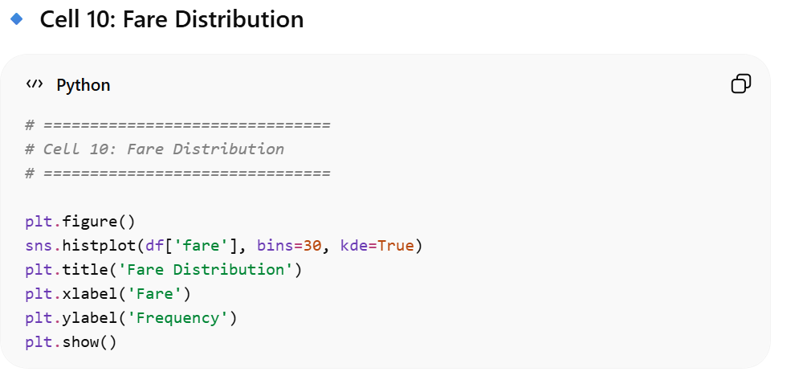
🔹 Cell 11: Family Features (SibSp, Parch, Alone)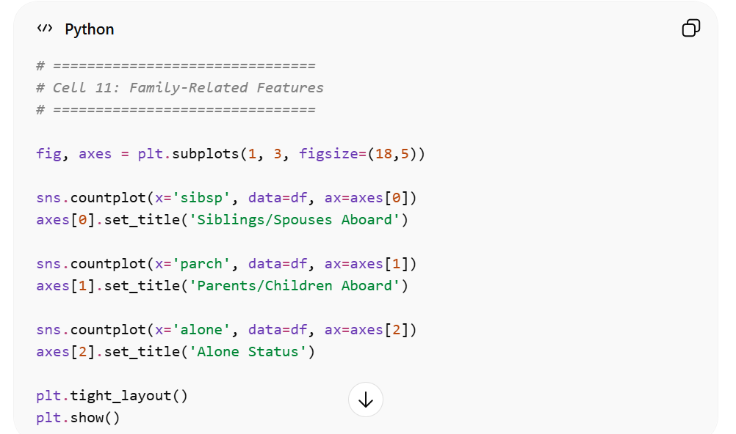
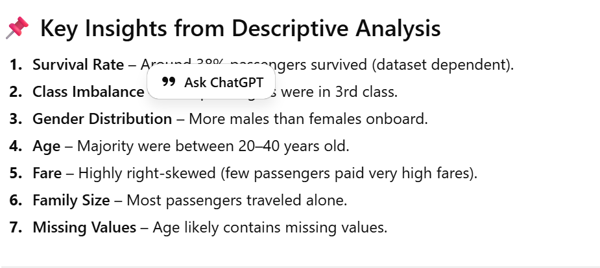

Task 3 – Check for missing values
Prompt:
Task 3. Check for the missing values in the important columns
The above code was already executed in the same google Colab, so do not repeat the same code which is already executed

Screenshot:
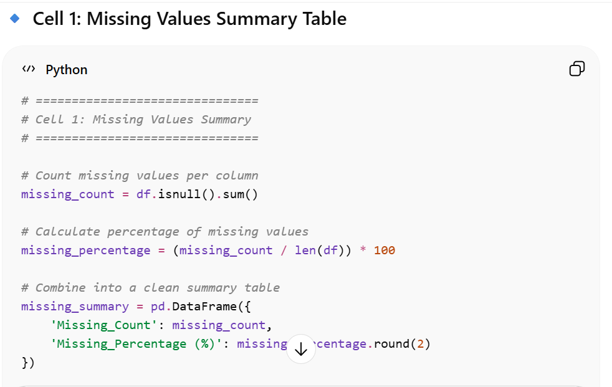
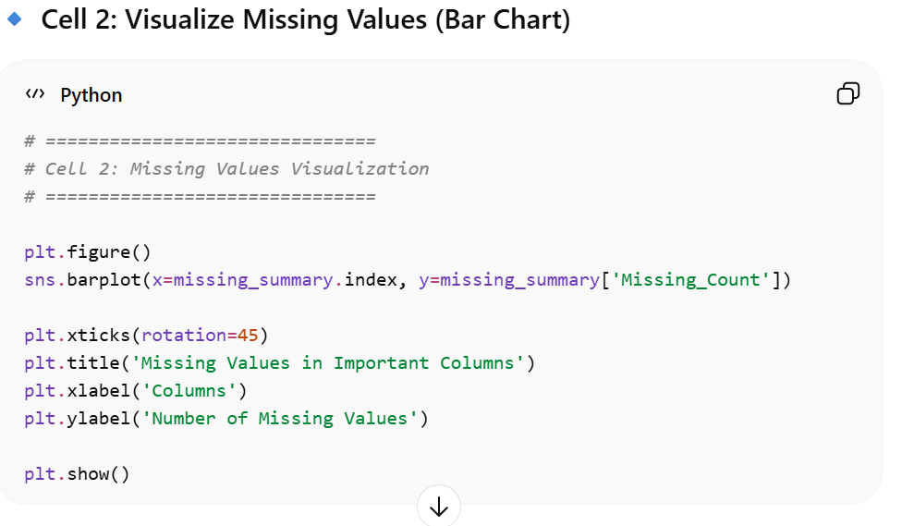
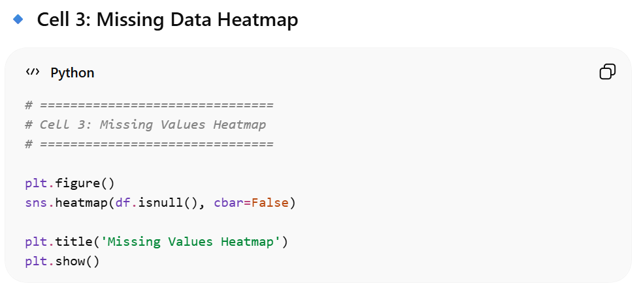
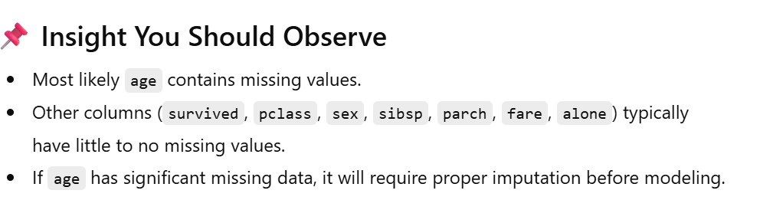
Task 4 – Check for Outliers:
Prompt:
Task 4. Please check for outlier values.
Screenshot:
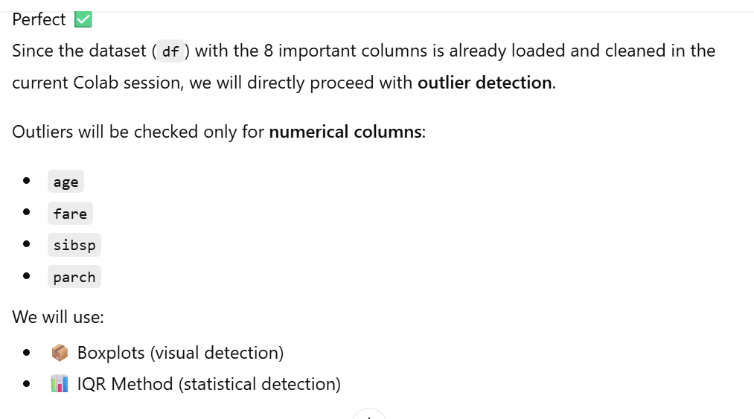
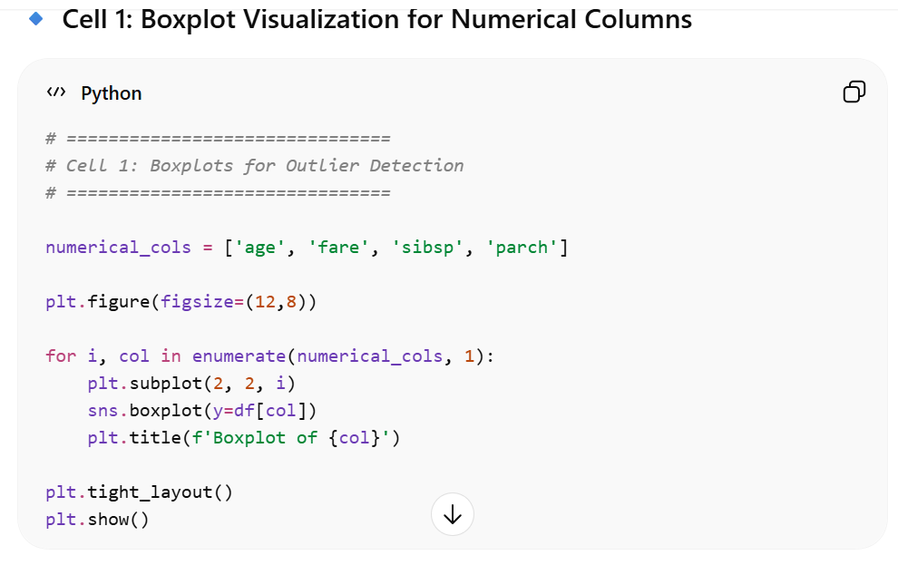
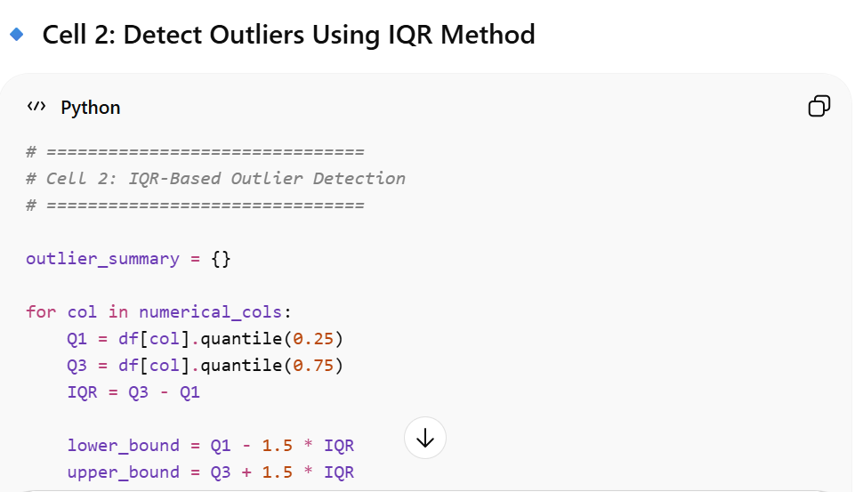
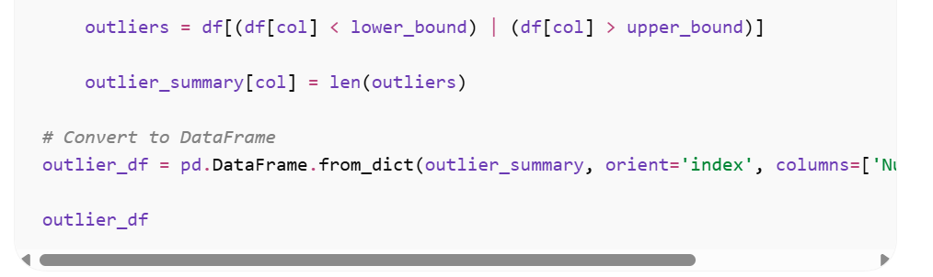
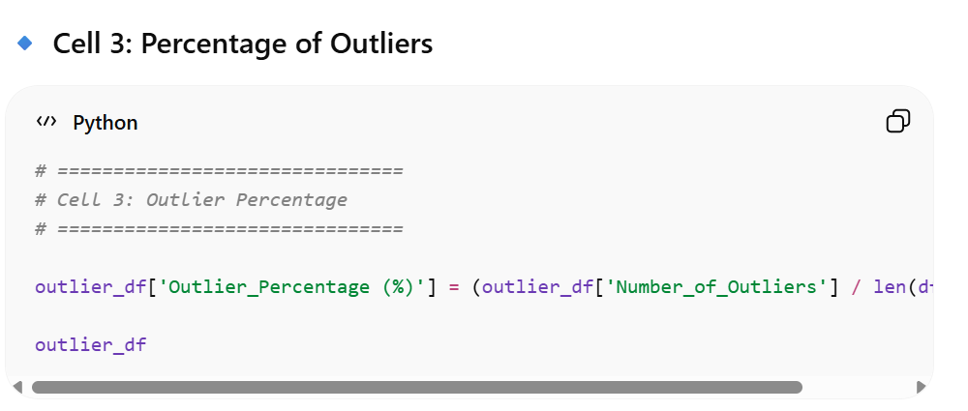
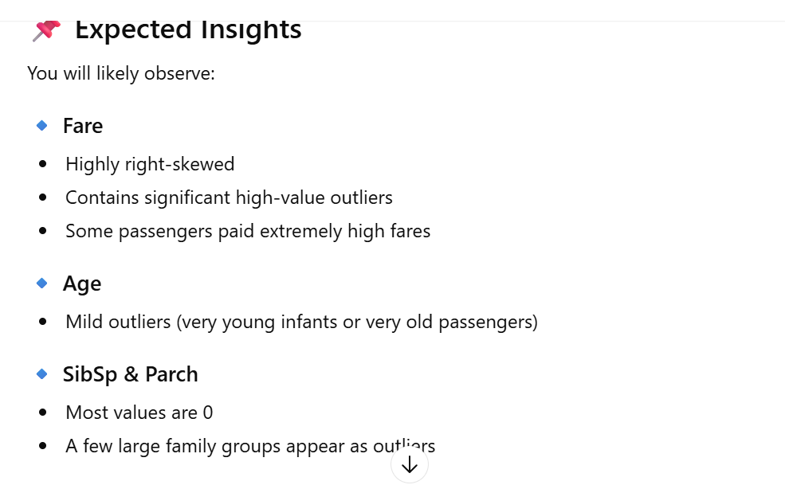
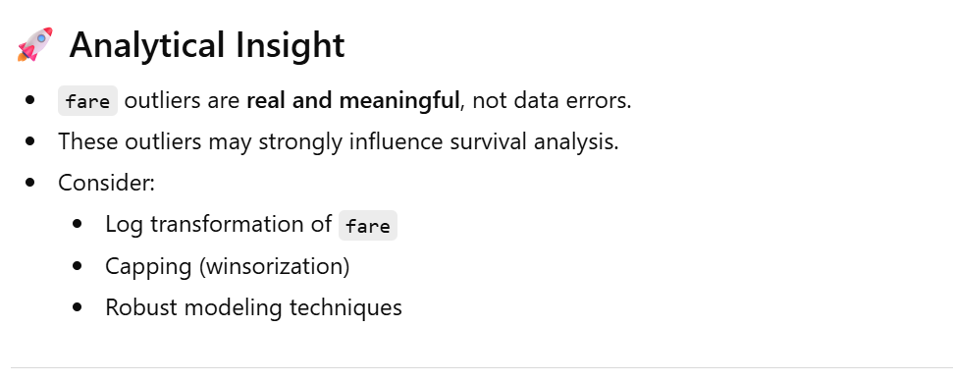
Task 5 – Univariate Analysis (Visualize the distribution of a column)
Prompt:
Task 5. Please perform univariate analysis.
Screenshot:
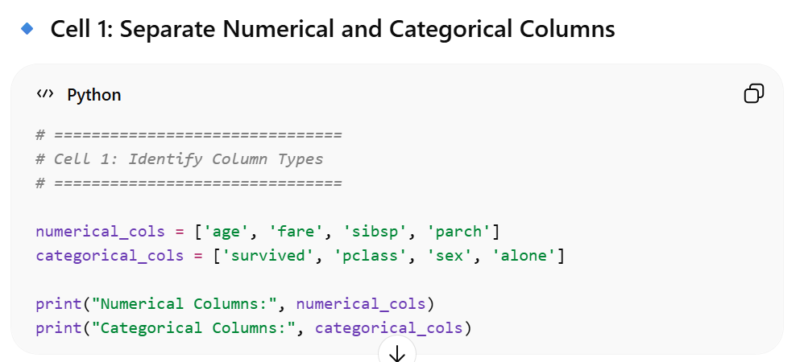
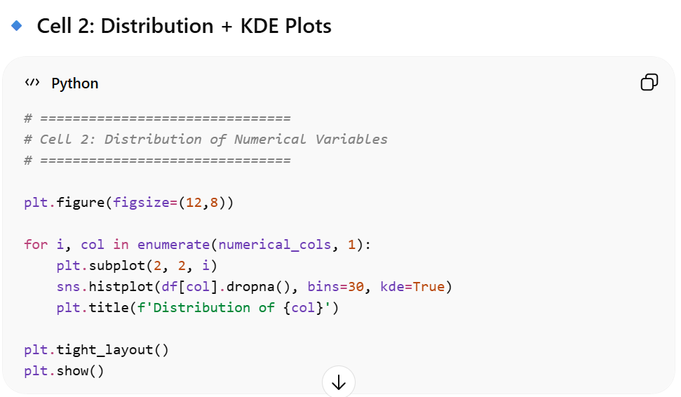
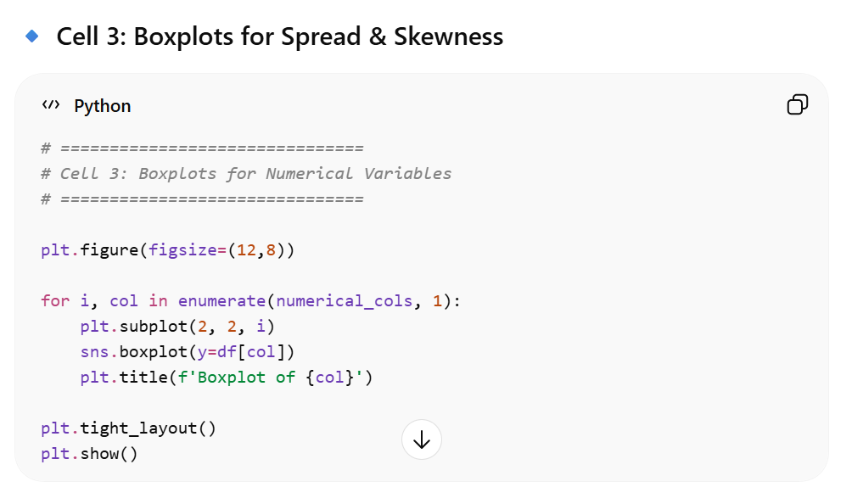
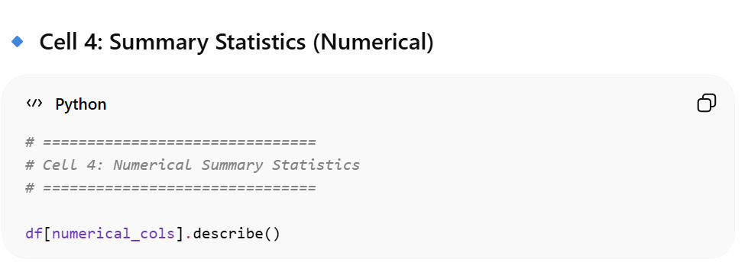
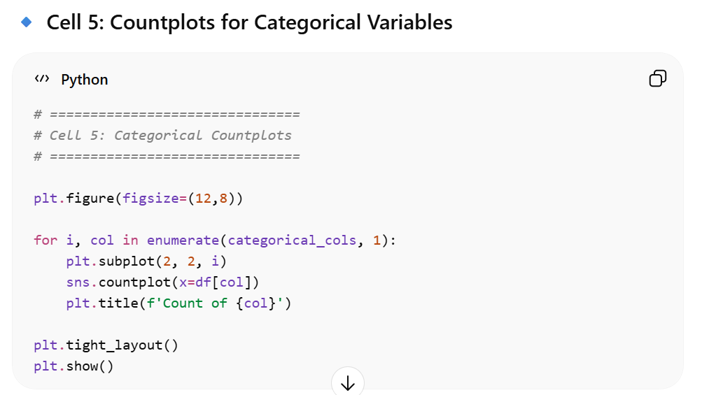
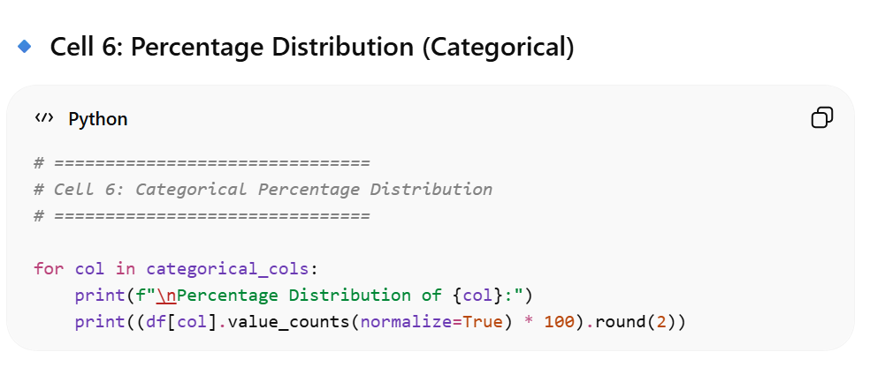
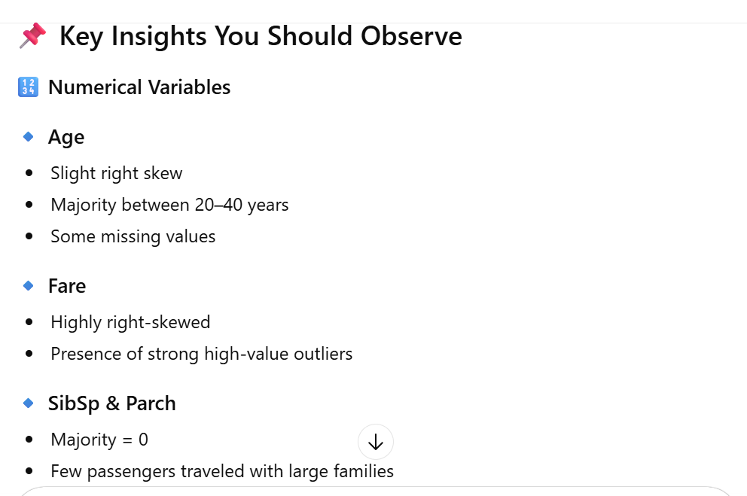
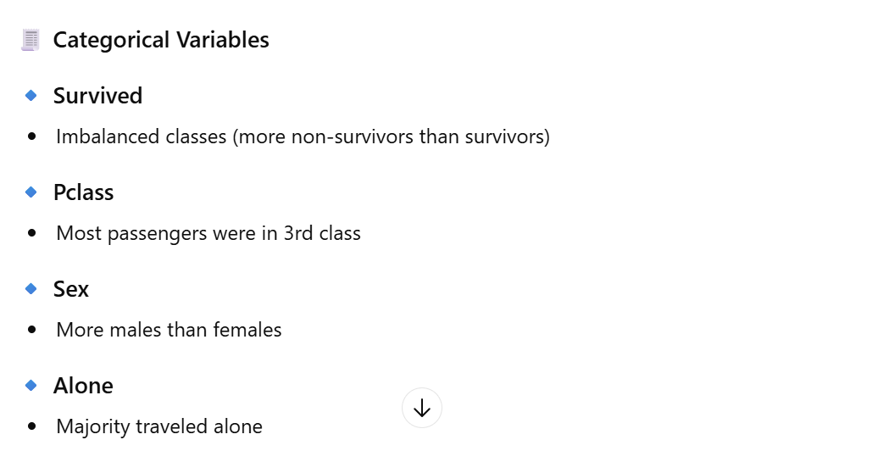
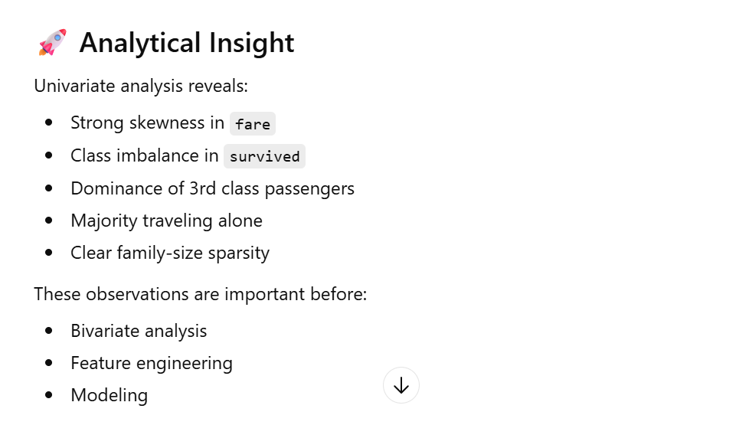
Task 6 – Bi-variate Analysis (Relationship between main column (Survived/ Tips) and other 4 important columns one-by-one)
Prompt:
Task 6. Perform bivariate analysis with survived
Screenshot:

